AEM Search Best Practices
Adobe Experience Manager Assets provides robust asset search methods that help you achieve higher content velocity. Sometimes, finding the right asset can be arduous and time-consuming if you only use the generic search capabilities of Experience Manager. Search assets capability is central to the usage of a digital asset management system - be it for further use by creatives, for robust management of assets by the business users and marketers, or for administration by DAM administrators.
This help document contains best practices of AEM search with the help of various scenarios to assist AEM users to perform basic to advanced level search.

Access Experience Manager Search {#access-experience-manager-search}
Following are the basic steps to perform in Experience Manager before you begin your search:
- Go to Assets > Files in Experience Manager and click the search icon on the top bar. Alternatively, use a forward slash (/) to open the Omni Search field.
- Location:Assets and Path:/content/dam are pre-selected to limit the search scope to your Experience Manager Assets repository. If you navigate to any other folder, Path:/content/dam/<folder name> displays in the Omni Search field to limit the search scope to the current folder.

Simple Search {#simple-search}
Scenario 1: Perform a basic search using a classic car as the search keyword.
The keyword search is not case-sensitive and is a full-text search (across the popular metadata fields). If more than one keyword is used, AND is the default operator between the keywords, thus, need not to write AND between the keywords.
The search results that match all search terms in metadata fields are displayed first, followed by the search results that match any of the search terms in the smart tags. The approximate order of display of search results is:
- Matches of Classic Car in the various metadata fields.
- Matches of Classic Car in smart tags.
- Matches of Classic or of Car in smart tags.
Specify classic car as the search keyword and click Search. You can view the search suggestions in a drop-down list as you type the keyword. The search suggestions are based on the historical searches performed on your Experience Manager deployment. If you cannot view the appropriate assets in the drop-down menu, press the Enter key to view the list of results. The results are sorted by relevance, starting from the closest matches.

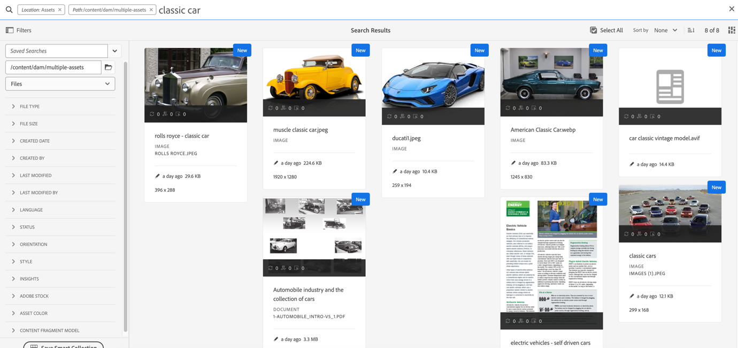
You can make the search more specific by adding your search keyword in double quotes (" "). The search criteria look like - "classic car".

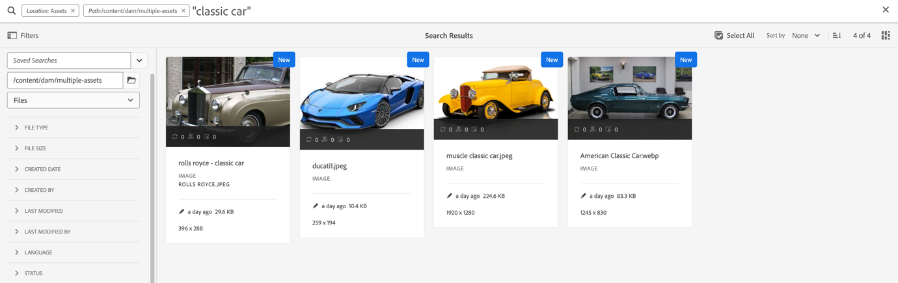
[Watch a video to perform a simple search in AEM Assets] ()

Files and folders {#files-folders}
Scenario 2: Search for all files using the classic car keyword within the automobile folder.
Files and folders filter helps you narrow down your search. Use Files, Folders, or Files and Folders options available in the drop-down list based on your requirement.
- Use the [!UICONTROL Files] option when you need to search specifically for files at a specific path within the repository. You do not need to search for folders within the defined path.
- Use the [!UICONTROL Folders] option when you need to limit your search to folders at a specific path.
- Use the [!UICONTROL Files and Folders] option if you need to search through all assets available at the specified path within the repository.
To achieve this scenario 2:
- Specify classic car as the search keyword and click Search.
- Click Filters and define the folder path for the automobile folder. For example, /content/dam/multiple-assets/automobile Select the folder from the path and navigate to the required folder if you want to search within the specific folder.
- Select Files from the drop-down list to display all files with the keyword classic car.
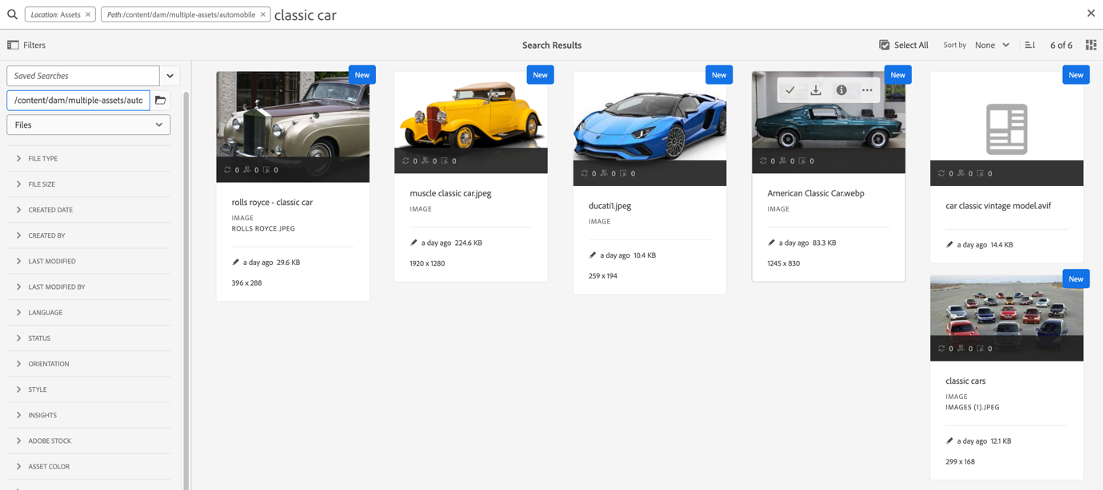
[Watch a video to perform search in AEM Assets using Files and Folders] ()

Operators {#operators}
Scenario 3: Search for Classic Car or Car keywords using various operator combinations to narrow down your search.
Experience Manager allows you to use a combination of various operators to enhance your search experience. The supported operators are:

AND operator {#and-operator}
AND operator is the default operator between two keywords in Omni Search. For example, when you type classic car in the search bar, the results with classic and car keywords appear in your search results, by default.



OR operator {#or-operator}
When you want to be specific with the search results and want an option in the search results, you can use the OR operator. For example, the classic OR car keyword provides search results with the either of keywords in their metadata.

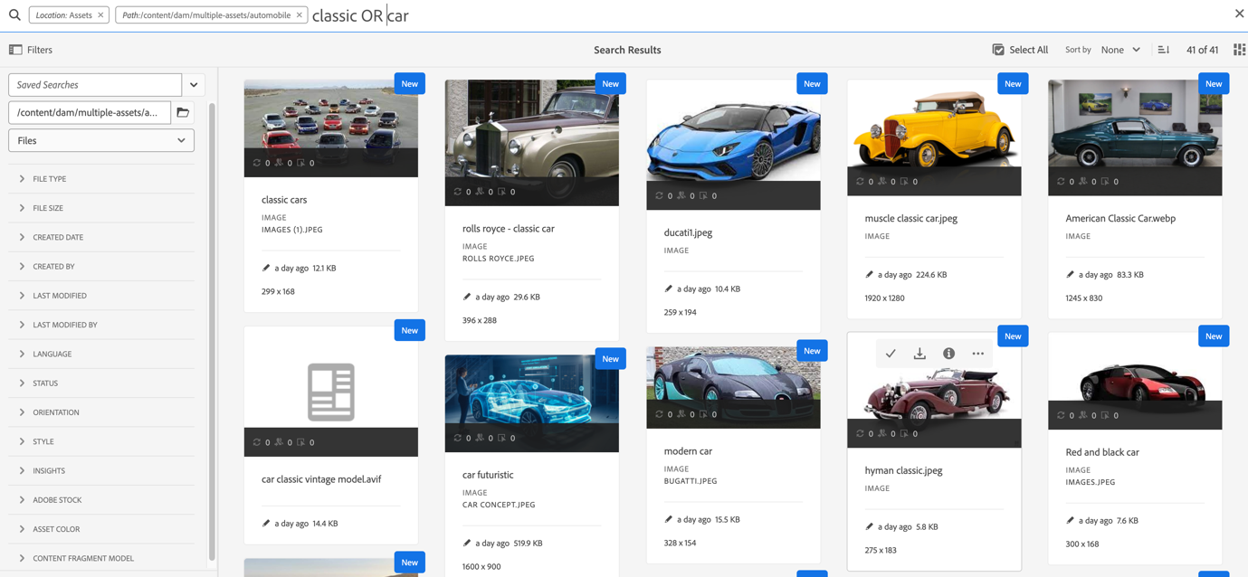

NOT operator {#not-operator}
When you want to retrieve results excluding some keywords, you can use the NOT operator. The NOT operator uses the hyphen (-) symbol to direct AEM search what to exclude from the search results. For example, the car - classic search query that specifies metadata that contains car but excludes classic.

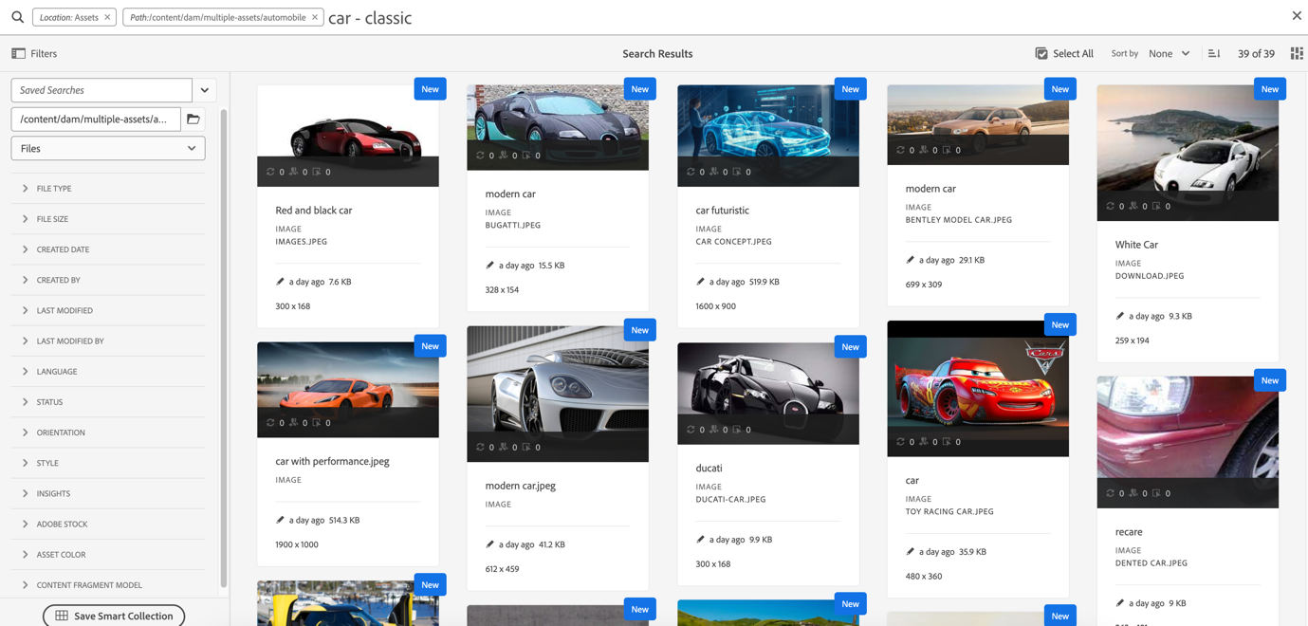

Similarly, you can search for all cars but not jeep. The query looks like: car - jeep. It displays all the assets with metadata car but excludes assets with metadata jeep.
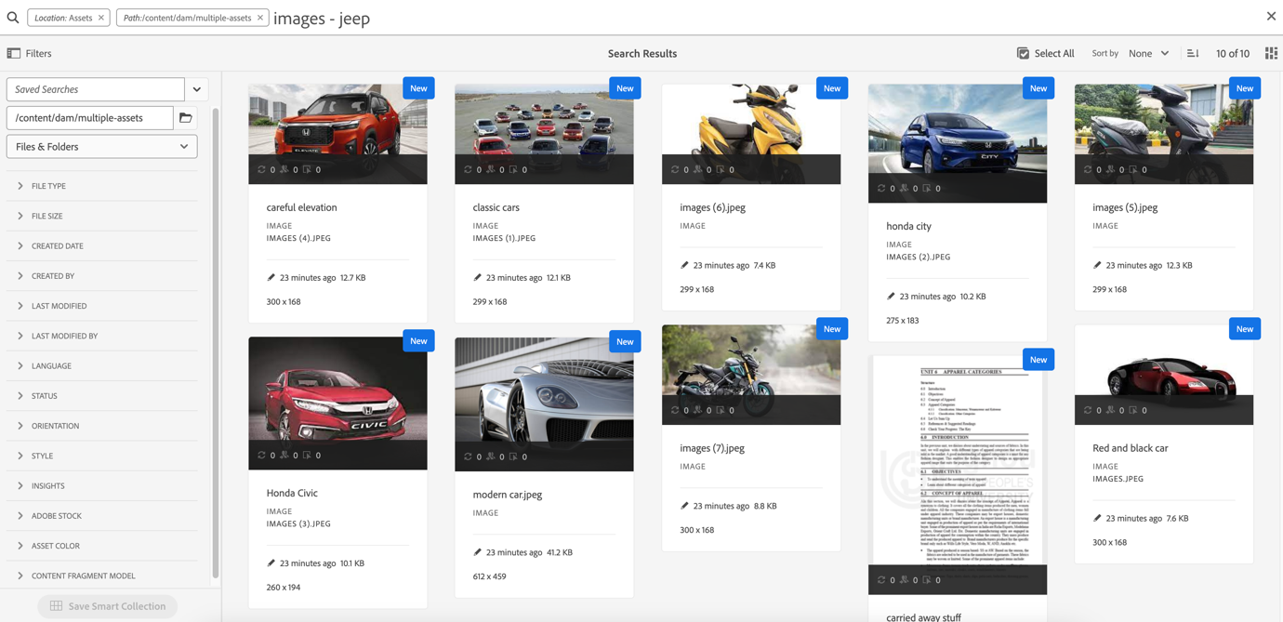

Wildcards {#wildcards}
Wildcards are used to replace one or more characters in the search. There are two wildcards used to perform the search - Question mark (?) and Asterisk (*). Question mark symbol is used to search a single character, whereas, asterisk symbol is used to search multiple characters.

Question mark (?) {#question-mark}
The question mark symbol can be used as a conditional operator to ease your search in Experience Manager.
- car? query matches the word with one character after car. For example, cart.
- ?car query matches the word with one character before car. For example, scar.
- car???? query matches the word with four characters after car. For example, carwash.

Asterisk (*) {#asterisk}
Asterisk is a wildcard operator that is used to broaden your search by typing fewer characters. When you know the starting characters of the asset that you are searching for, but do not know the rest, you can use the asterisk operator in your search. For example, the *car query returns all the assets with postfix car available in their metadata. The results could be classic car, sports car, classic and sports car, and so on. Below are a few examples of using the asterisk operator in various ways:
- *car* returns all possible combinations.
- car* returns assets with carwash, carrier, carriage, and so on.
- *car returns assets with modern car, sports car, and so on.
[Watch a video to perform a search in AEM Assets using wildcards] ()

Filters {#filters}
Adobe Experience Manager provides various search filters which you can use to refine and segment your search using a scoped query. When you are unsure about the title or meta description of an asset, you can use various search filters to make your search more relevant. You can use search filters with or without typing a keyword. To open the filters panel, click the GlobalNav icon and select [!UICONTROL Filters].
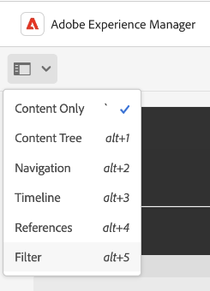
You can select single or multiple filters to refine your search in Adobe Experience Manager.
Scenario 4: Search for unpublished PDF file type documents with the classic car keyword in it.
To search for the above requirement, follow the steps below:
- Type classic car in the search bar.
- Go to Filters. Under [!UICONTROL File Type], expand [!UICONTROL Documents], further expand [!UICONTROL Word Processing].
- Select [!UICONTROL PDF].
- Go to [!UICONTROL Status] > [!UICONTROL Publish] > [!UICONTROL Unpublished] .
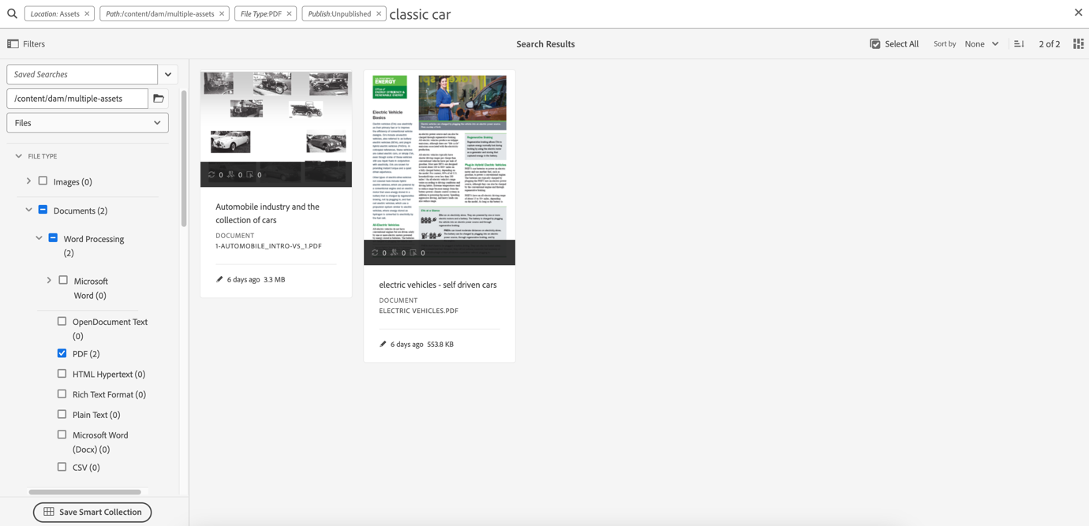
[Watch a video to perform search in AEM Assets using various filters] ()

Scenario 5: Search for all images except PNG
When you are unsure about the title or meta description of an asset, you can use various search filters to make your search more relevant. Follow the steps below:
- Go to search filters.
- Go to Filters. Under [!UICONTROL File Type], expand [!UICONTROL Images] and select [!UICONTROL Web enabled]
- Deselect PNG.
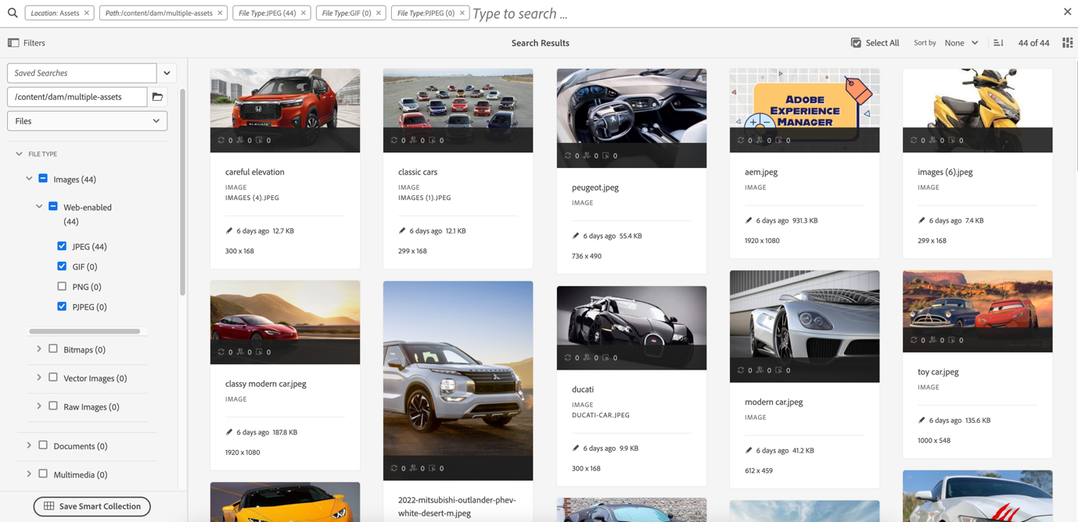

Advanced search {#advanced-search}
AEM search allows you to craft complex search queries with less effort. Following are the various examples to help you create complex search queries:
Scenario 6: Search for all documents in the Experience Manager repository with classic car in their metadata. The content of the document must contain classic car keyword in it.
Adobe Experience Manager allows you to add multiple criteria to your search. You can use a combination of keywords, operator(s), and filter(s) to narrow down your search results.
To perform a search for scenario 6:
- Type the classic car keyword in the search bar.
- Navigate to the filters panel and select Documents under File Type.
- Refine your search using the asterisk wildcard. Type "classic car" to search all assets that contain the classic car keyword.
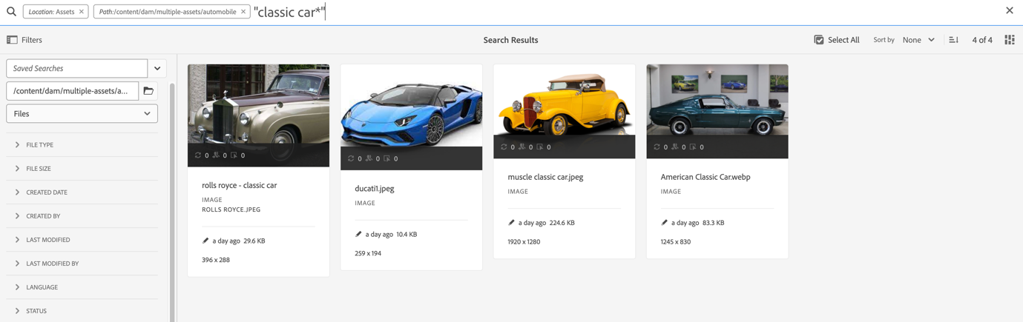

Scenario 7: Search for all documents in the Experience Manager repository in which the content of the document must include car but exclude classic. The same condition applies on metadata of an asset.
To perform a search for scenario 7:
Type the car - classic keyword in the search bar. Navigate to the filters panel and select Documents under File Type. The priority order of search is based on the following:
Priority 1: Metadata
Priority 2: Smart Tags

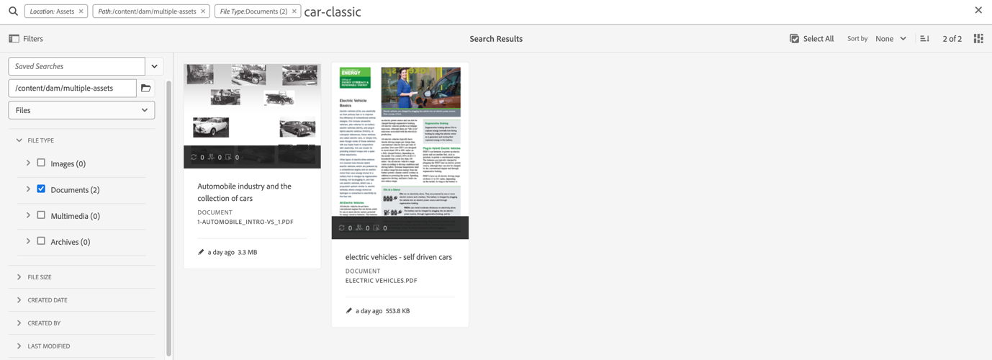
Scenario 8: Search for metadata tags with metadata jeep
You can capture a specific criteria using various search filters. Tag is a keyword that is assigned to an asset to make it identifiable among a large number of assets. For example, in this scenario, we are searching for assets with jeep tags in it. To do this, type tags:jeep in the search bar. Only assets that meet this criteria are listed in the search results.
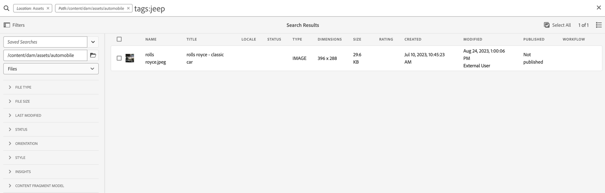

Scenario 9: Find similar match for red color car
While performing your search on AEM, you can filter your results by showing similar assets to the selected ones. You can use the Find Similar option to narrow down your search to the exact or similar match of the searched Asset. For example, you want to search for duplicate assets. To do this, follow the steps below:
- Search the asset as per your requirement.
- Hover over the asset > click ellipsis > select [!UICONTROL Find Similar]. or Select the asset > navigate to the ellipsis at the top right > select [!UICONTROL Find Similar].
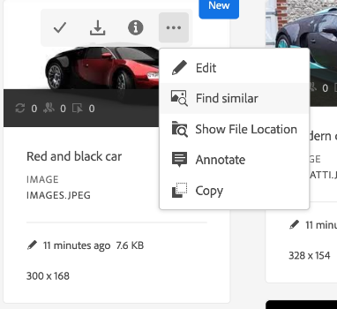
- Notice the search bar. The thumbnail of the selected asset appears on the search bar indicating your search requirement. As a result, it returns the similar looking assets.

Custom search facets {#custom-search-facets}
Search facets in Adobe Experience Manager let you search for assets in multiple ways rather than in a single, pre-determined, or taxonomic order. You can customize search facets and add predicates as per your requirement. Read Search Facets for the step-by-step guide about adding a custom predicate.
Scenario 10: Search assets based on Sku ID
Scenario 11: Search specific assets based on their last modified or expiry date
Date constraints allow you to narrow down your custom search to a particular period, for example, using the time period search filters. To search for the above requirement, type classic car in the search bar. Select the date range in the [!UICONTROL Created Date] and [!UICONTROL Last Modified] date filters.

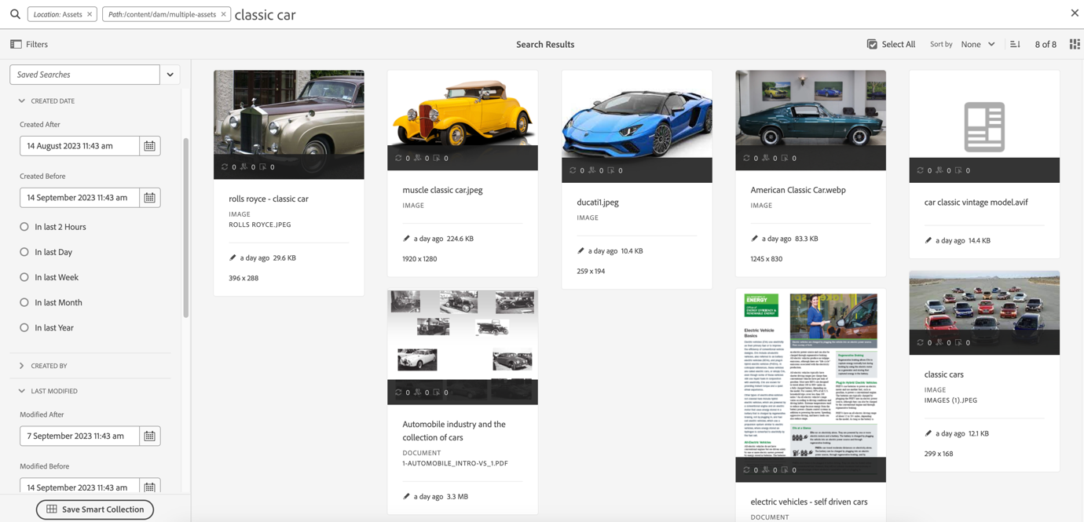

Boosting relevance of keywords {#boosting-keywords}
You can improve the relevance of keywords for particular assets to help boost searches based on the keywords. In other words, the images for which you promote specific keywords appear at the top of the search results when you search based on these keywords.
- From the Assets user interface, open the properties page for the asset. Click [!UICONTROL Advanced] and click [!UICONTROL Add] under [!UICONTROL Elevate for search keywords].
- In the Search Promote box, specify a keyword for which you want to boost the search for the image and then click [!UICONTROL Add]. You can specify multiple keywords in the same way.
- Click [!UICONTROL Save & Close]. The asset which you promoted for this keyword appears among the top search results.

Notable things while performing a search in Experience Manager {#notable-things}
- Provide metadata information of the asset to prepare your asset searchable by the Omni Search algorithm. Ensure that the metadata information of the asset is updated.
- Use double quotes (" ") to make your search exact and to the point.
- Cross-check the path that you are looking into. Select the appropriate option among folder, file, or file and folder to run your search query at the appropriate location.
- You can check the filters that you are applying to your search on the Omni Search bar.
- In case you are not getting any results, cross-check the path you are looking into. Also, check the folder that you are performing your search from. For example, if you are performing a search inside the 'Automobile folder' but the keyword that you are using is related to 'Apparels' then the search results are inappropriate.
- Check-in case you have added whitespace before the keyword that you are searching for.
- Using a mix and match of keywords, operators, and filters can ease and level up your search experience.

